Lesson Plan Title:­­­­­­­­­­­­­ “Emotion books ” Length: Three Classes
Grade: 1st grade

Note: Before you plan and write art experiences; pre-assess your students based on the proposed concepts, enduring understandings, and objectives of the unit/lesson(s). You may also gather this information from (previous) teachers, by reviewing already completed art work, consulting curriculum materials, etc., to get a better understanding of what content students already know and what they will need to know to be successful.

Pre-Assessment:
This will need to be done prior to teaching your lesson. Outline the method you will use to determine the skill/knowledge level of your students based on the concepts/enduring understandings/objectives of the lesson. (Hint: turn these into questions.) Be specific in describing what you would recognize as proficient skill/knowledge.
What is printmaking?
Why would you use printmaking instead of drawing directly onto the paper?
How would you transfer marker onto the paper using printmaking?
Can you tell a story of when you felt an emotion and why you felt that way?

Performance:
What will students accomplish as a result of this lesson? This can be presented to students in the form of a story. In this narrative the students take on a role and create a learning product about a specific topic for a certain audience. (RAFT – Role / Audience / Format / Topic)
You are artists who are putting together a book of emotions to help children younger than you understand the different feelings. You will do this by printmaking with markers.

Concepts:
List the big ideas students will be introduced to in the lesson. These ideas are universal, timeless and transferrable. Examples of concepts used in art might include: Composition, Patterns, Technique, Rhythm, Paradox, Influence, Style, Force, Culture, Space/Time/Energy, Line, Law/Rules, Value, Expressions, Emotions, Tradition, Symbol, Movement, Shape, Improvisation, and Observation Look for concepts in the standards, content specific curriculum, etc.
Expressions
Emotion
Color
Shape

Enduring Understanding (s):
Enduring Understandings show a relationship between two or more concepts; connected with an active verb. The best enduring understandings not only link two or more concepts; but demonstrate why this relationship is important. Like concepts, they are timeless, transferrable and universal.
Artists draw inspiration from memories and emotions by letting them influence the colors, shapes and patterns used in their artwork.

Standards: (All lessons should address all standards.)
1. Observe and Learn to Comprehend
2. Envision and Critique to Reflect
3. Invent and Discover to Create
4. Relate and Connect to Transfer

Objectives/Outcomes/Learning Targets:
Objectives describe a learning experience with a condition → behavior (measurable) → criterion. Aligned to: Bloom’s – Standards – GLEs - Art learning and, when appropriate, Numeracy, Literacy and Technology. Should be written as: Objective. (Bloom’s: _____ - Standard: _____ - GLE: _____ -Art learning: _____ -Numeracy, Literacy, and/or Technology)
After viewing a video clip, students will be able to describe physical features of each character that represents a feeling by clearly locating the characteristics of color and shape and expressive facial features to interpret and discuss what emotion the artist is trying to convey. (Identify/Discuss, Observe/learn/comprehend, GLE 1, Discussing works of art, Literacy )

After observing artworks, students will be able to interpret by identifying personal feelings motivated by works of art. (Identify/Discuss/Interpret, Observe/learn/comprehend, GLE 1, Interpreting art, literacy)

After choosing 5 emotions from the list, students will be able to recall times when they felt the emotions to sketching in their sketchbooks. (Recall/Remember, Envision/reflect, GLE 1, planning ideation, Literacy)

After sketching in their sketchbooks, students will be able to create a visual representation of several emotions by using art media to express their feelings. (Developing/Modifying, Create/Invent/Discover, GLE 1, artmaking, literacy)

After making their emotion books, students will be able to relate and connect by describing their own personal stories of when they felt the emotion and listening to the stories of their classmates. (Discussing/Questioning/Critique, Relate/Connect/Transfer, GLE 1, Interpreting and connecting to artworks made by others, literacy)

Differentiation:
Explain specifically how you have addressed the needs of exceptional students at both end of the skill and cognitive scale. Describe the strategies you will use for students who are already proficient and need growth beyond what you have planned for the rest of the class, as well as modifications for students with physical and/or cognitive challenges. Students must still meet the objectives.

Differentiation:  (Multiple means for students to access content and multiple modes for student to express understanding.) | Access (Resources and/or Process) | Expression (Products and/or Performance)
 | -Students can use gloves if they don’t like the feeling of the paper mache | -Students can paint on the features or mold them out of aluminum foil instead of using the paper pulp to create them.
Extensions for depth and complexity: | Access (Resources and/or Process) | Expression (Products and/or Performance)
 | -Students can create a unique shape out of tin foil instead of fitting it to their face | -Students can create a monster mask that represents two different emotions one on each half of the face.

Literacy:
List terms (vocabulary) specific to the topic that students will be introduced to in the lesson and describe how literacy is integrated into the lesson.
-emotions
-paper mache

Literacy is integrated into this lesson when the students create their artist statement about the mask that they created.

Materials:
Must be grade level appropriate. List everything you will need for this lesson, including art supplies and tools. (These are the materials students will use.) List all materials in a bulleted format.
Paper pulp
Paper mache
Aluminum foil
Scissors
Buckets
Paint

Resources:

List all visual aids and reference material (books, slides, posters, etc. Be specific; include title, artist, etc. Make reference to where the material can be found. (These are the resources used by the teacher to support/develop the lesson.) List all resources in a bulleted format.
Jean-Francois Millet, Man with a Hoe
Seurat, Le Cirque
Nakamura Shikan As Higuchi no Jiro
https://www.youtube.com/watch?v=Mx41SPMLBMg

Preparation:
What do you need to prepare for this experience? List steps of preparation in a bulleted format.
-create paper mache mix
-pretear strips of newspaper
-gather materials
-print out emotion sheet for students to fill out
-print out artist statement

Safety:

Be specific about the safety procedures that need to be addressed with students. List all safety issue in a bulleted format.
-Wash your hands in the bucket not the sink, to avoid clogging the sink!

Action to motivate/Inquiry Questions:
Describe how you will begin the lesson to stimulate students interest. How will you pique their curiosity and make them interested and excited about the lesson? What inquiry questions will you pose? Be specific about what you will say and do to motivate students and get them thinking and ready to participate. Be aware of the varying range of learning styles/intelligences of your students. Some ideas might include: telling a story, posing a series of questions, role-playing, etc.
Teachers will
show this video:https://www.youtube.com/watch?v=Mx41SPMLBMg
“When you look at this monster how do you know what emotion it is?” and then students will play an emotion guessing game
for the guessing game they can tell their partner a time when they felt that way and then the partner guesses what their emotion is

Ideation/Inquiry:
Ideation is the creative process of generating, developing, and communicating new ideas, where an idea is understood as a basic element of thought that can be visual, concrete or abstract. List and describe inquiry questions and processes you will engage students in to help them develop ideas and plans for their artwork.
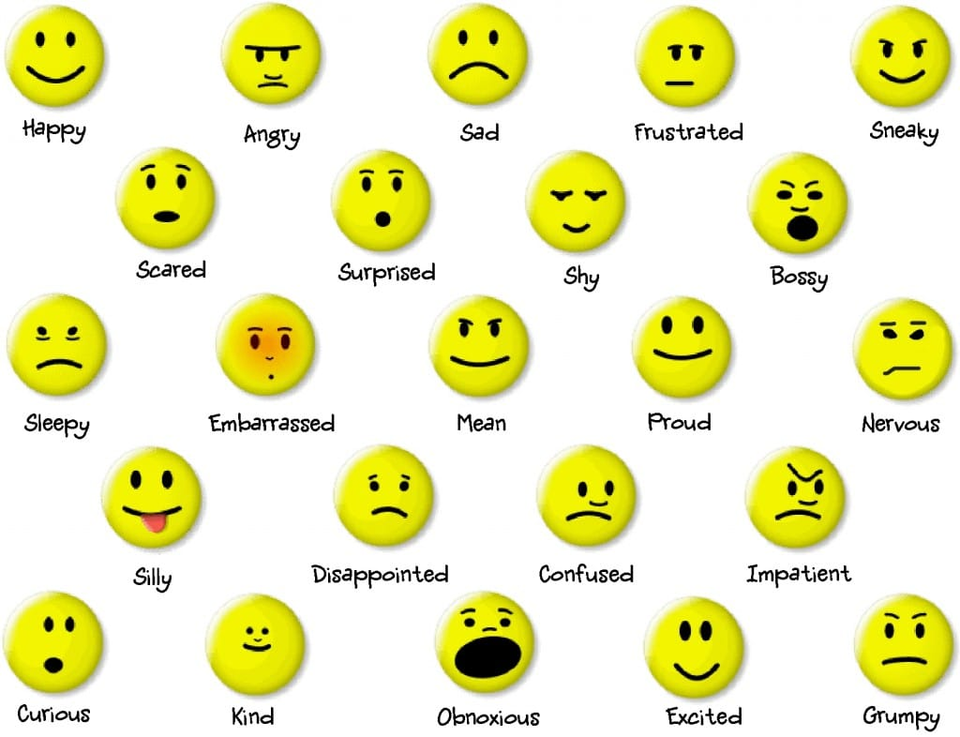
Students will circle a feeling and sketch a time that they felt that way in their sketchbooks

Instruction:
Give a detailed account (in bulleted form) of what you will teach. Be sure to include approximate time for each activity and instructional methodology: skills, lecture, inquiry, etc. Include motivation and ideation/inquiry where appropriate; including what student will understand as a result of the art experience

Day 1 | Instruction - The teacher will... (Be specific about what concepts, information, understandings, etc. will be taught.) Identify instructional methodology. KNOW (Content) and DO (Skill)  The teachers will instruct students to gather on the carpet. The clip from the movie inside out will play and then the teachers will ask “What emotions did you see and how did you know which emotion was which? What are the expressions on the faces of each emotion? When you look at each monster how did you know what emotion it was? The teachers will then show students three different artworks that portray different feelings? (Jean-Francois Millet, Man with a Hoe, Seurat, Le Cirque and Nakamura Shikan As Higuchi no Jiro) What is going on it these artworks? What emotions do you think the people in the artworks are feeling and why?  Next the teacher will instruct the students to gather around her and the  The teacher will demonstrate how to use plexiglass and markers to make a print.  - Fill the whole plexiglass with marker, draw what you want to transfer onto your paper.  - If you mess up on drawing, you can use a wet paper towel to wipe away the marker.  - Once your plexiglass is fully covered, you can line up at the paper station and Laine or Sami will help you dip your paper into the water and dry it off.  - Then you will put the paper on top of the glass, make sure the paper stays in place or it the marker will smear. Very carefully smooth down the paper with your hand and apply pressure so that the marker transfers to your paper.  - Peel off the paper and experience the magic of printmaking!  The teacher will instruct students that they have 20 minutes to experiment with this process before creating the drawings for their books.  Next the teacher will instruct students to use their sketchbooks to sketch out at times that they felt the 5 emotions.  The teacher will demonstrate sketching.  The teacher will instruct students that they have the rest of class to make their prints for their book.  The teacher will instruct students to cleanup by assigning specific jobs. | Learning - Students will... i.e.: explore ideation by making connections,  comparing, contrasting; synthesize possibilities for each painting technique; etc. (Be specific about what will be the intended result of the instruction as it relates to learning.) UNDERSTAND  Students will be able to explore ideation by making connections between colors, shapes and physical features and emotions.  Students will explore ideation by understanding how stories can portray emotions.  Students will reflect upon how memories relate to emotions. | Time  Total:  1 hr 45  10 min  10 min  20 min  5 min  20 min  10 min

Student reflective/inquiry activity:
Sample questions and activities (i.e. games, gallery walk, artist statement, interview) intended to promote deeper thinking, reflection and refined understandings precisely related to the grade level expectations. How will students reflect on their learning? A participatory activity that includes students in finding meaning, inquiring about materials and techniques and reflecting about their experience as it relates to objectives, standards and grade level expectations of the lesson.)
Students will fill out an artist statement:

My mask represents the emotion monster for ________. A time I felt this emotion was when _________.

Post-Assessment (teacher-centered/objectives as questions):  Have students achieved the objectives and grade level expectations specified in your lesson plan? | Post-Assessment Instrument:  How well have students achieved the objectives and grade level expectations specified in your lesson plan? Include your rubric, checklist, rating scale, etc.
Did students represent an emotion with their masks?  Did students use their sketchbook to tell a story about a time they felt the emotion that they chose?  Did students use two-dimensional painting technique?  Did students make connections to the art created by their classmates? | Criteria Advanced Proficient Developing  Did students represent an emotion with their masks? Student used both shape and color and patterns to portray the emotion of their mask Students represented their emotion by using at least two of the following three: color, shape, pattern Students only use a facial expression (ex. Frown, smile) to represent their emotion

Self-Reflection:
After the lesson is concluded write a brief reflection of what went well, what surprised you, and what you would do differently. Specifically address: (1) To what extent were lesson objectives achieved? (Utilize assessment data to justify your level of achievement.) (2) What changes, omissions, or additions to the lesson would you make if you were to teach again? (3)What do you envision for the next lesson? (Continued practice, reteach content, etc.)
NA

Appendix: Include all handouts, prompts, written materials, rubrics, etc. that will be given to students.

