Lesson Plan Title:­­­­­­­­­­­­­ “Ahoy come aboard my ship!” Length: Three Classes
Grade: 1st grade

Note: Before you plan and write art experiences; pre-assess your students based on the proposed concepts, enduring understandings, and objectives of the unit/lesson(s). You may also gather this information from (previous) teachers, by reviewing already completed art work, consulting curriculum materials, etc., to get a better understanding of what content students already know and what they will need to know to be successful.

Pre-Assessment:
This will need to be done prior to teaching your lesson. Outline the method you will use to determine the skill/knowledge level of your students based on the concepts/enduring understandings/objectives of the lesson. (Hint: turn these into questions.) Be specific in describing what you would recognize as proficient skill/knowledge.
Students will be given a small piece of paper (with gesso on it)
- This will give students time to get a feel of how acrylic works
- We will be able to see how well the students can control the paint

Performance:
What will students accomplish as a result of this lesson? This can be presented to students in the form of a story. In this narrative the students take on a role and create a learning product about a specific topic for a certain audience. (RAFT – Role / Audience / Format / Topic)
You are a pirate who is ready to go on a journey to find buried treasure, design your ship by painting on canvas with acrylic.

Concepts:
List the big ideas students will be introduced to in the lesson. These ideas are universal, timeless and transferrable. Examples of concepts used in art might include: Composition, Patterns, Technique, Rhythm, Paradox, Influence, Style, Force, Culture, Space/Time/Energy, Line, Law/Rules, Value, Expressions, Emotions, Tradition, Symbol, Movement, Shape, Improvisation, and Observation Look for concepts in the standards, content specific curriculum, etc.
Shape
Two-dimensional design
Composition
Pattern
Color

Enduring Understanding (s):
Enduring Understandings show a relationship between two or more concepts; connected with an active verb. The best enduring understandings not only link two or more concepts; but demonstrate why this relationship is important. Like concepts, they are timeless, transferrable and universal.
Artists can create a two-dimensional compositions through the use of shapes and patterns.

Standards: (All lessons should address all standards.)
1. Observe and Learn to Comprehend
2. Envision and Critique to Reflect
3. Invent and Discover to Create
4. Relate and Connect to Transfer

Objectives/Outcomes/Learning Targets:
Objectives describe a learning experience with a condition → behavior (measurable) → criterion. Aligned to: Bloom’s – Standards – GLEs - Art learning and, when appropriate, Numeracy, Literacy and Technology. Should be written as: Objective. (Bloom’s: _____ - Standard: _____ - GLE: _____ -Art learning: _____ -Numeracy, Literacy, and/or Technology)
After listening to a story, students will be able to relate by using their imagination to come up with their own idea. (Comprehend/Reflect/Critical Reflection and Art & Culture/Literacy)

When looking at famous artworks, students will be able to reflect by interpreting and pointing out specific elements of design (shape, pattern, color).

After filling out ideation menus, students will be able to envision ideas about what their pirate ship will look like by circling the options that they want to include and creating a sketch. (Comprehend/Reflect/Transfer)

Using acrylic paint, students will be able to use painting techniques to create a background and pirate ship by using shapes and pattern. (Create/Create/Materials, Tools, Techniques)

Through observation, students will be able to connect to the art created by their classmates through a share and critique. (Observe/reflect/connect)

Differentiation:
Explain specifically how you have addressed the needs of exceptional students at both end of the skill and cognitive scale. Describe the strategies you will use for students who are already proficient and need growth beyond what you have planned for the rest of the class, as well as modifications for students with physical and/or cognitive challenges. Students must still meet the objectives.

Differentiation:  (Multiple means for students to access content and multiple modes for student to express understanding.) | Access (Resources and/or Process) | Expression (Products and/or Performance)
 | -Use markers and pastels instead of paint | -Draw the images with markers and pastels if students don’t want to use paint
Extensions for depth and complexity: | Access (Resources and/or Process) | Expression (Products and/or Performance)
 |  | NA

Literacy:
List terms (vocabulary) specific to the topic that students will be introduced to in the lesson and describe how literacy is integrated into the lesson.
Two-dimensional
Shape
Pattern

Students will be discussing their responses to a variety of artworks using personal interpretation. Students will be encouraged to use art vocabulary when appropriate.

Materials:
Must be grade level appropriate. List everything you will need for this lesson, including art supplies and tools. (These are the materials students will use.) List all materials in a bulleted format.
Sketchbooks
Canvases
Acrylic Paint
Paint brushes
Aprons
Paper plates (for paint)
Water trays
Towels to wipe paint brushes

Resources:

List all visual aids and reference material (books, slides, posters, etc. Be specific; include title, artist, etc. Make reference to where the material can be found. (These are the resources used by the teacher to support/develop the lesson.) List all resources in a bulleted format.
-Pirate book

Preparation:
What do you need to prepare for this experience? List steps of preparation in a bulleted format.
- Gesso canvases
- Get our pirate accents ready
- Make a treasure map

Safety:

Be specific about the safety procedures that need to be addressed with students. List all safety issue in a bulleted format.
General instructions about the care and respect of paint and brushes.
- How to clean paint brushes after using acrylic paint. If you want to change color, use a different paint brush or clean brush thoroughly

Action to motivate/Inquiry Questions:
Describe how you will begin the lesson to stimulate students interest. How will you pique their curiosity and make them interested and excited about the lesson? What inquiry questions will you pose? Be specific about what you will say and do to motivate students and get them thinking and ready to participate. Be aware of the varying range of learning styles/intelligences of your students. Some ideas might include: telling a story, posing a series of questions, role-playing, etc.
First read a story about a pirate ship. Then show students these paintings of ships. Ask the following questions:

What events do you see? What is going on?
What colors to you see? Are the colors repeated? Where? (Have student come up and point out.)

etc…………..
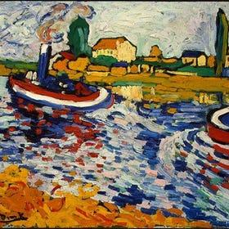
"Tugboat on the Seine, Chatou" (1906) by Maurice de Vlaminck 1906

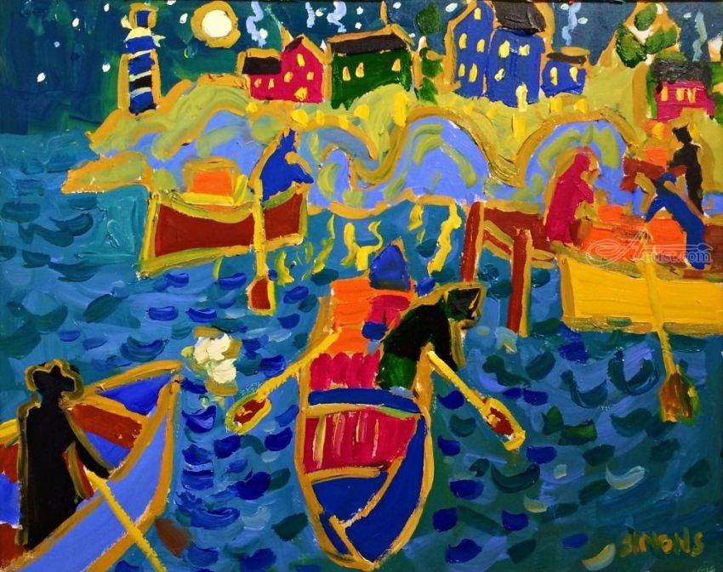
“Boating” by Brian Simonos, 2017
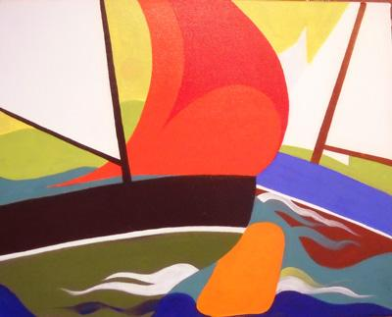
“Orange Bouy” by George Anderson

After showing these artworks, Laine will show her finished artwork with the cut-out ship pasted onto the background.

Ideation/Inquiry:
Ideation is the creative process of generating, developing, and communicating new ideas, where an idea is understood as a basic element of thought that can be visual, concrete or abstract. List and describe inquiry questions and processes you will engage students in to help them develop ideas and plans for their artwork.
Lesson menu:
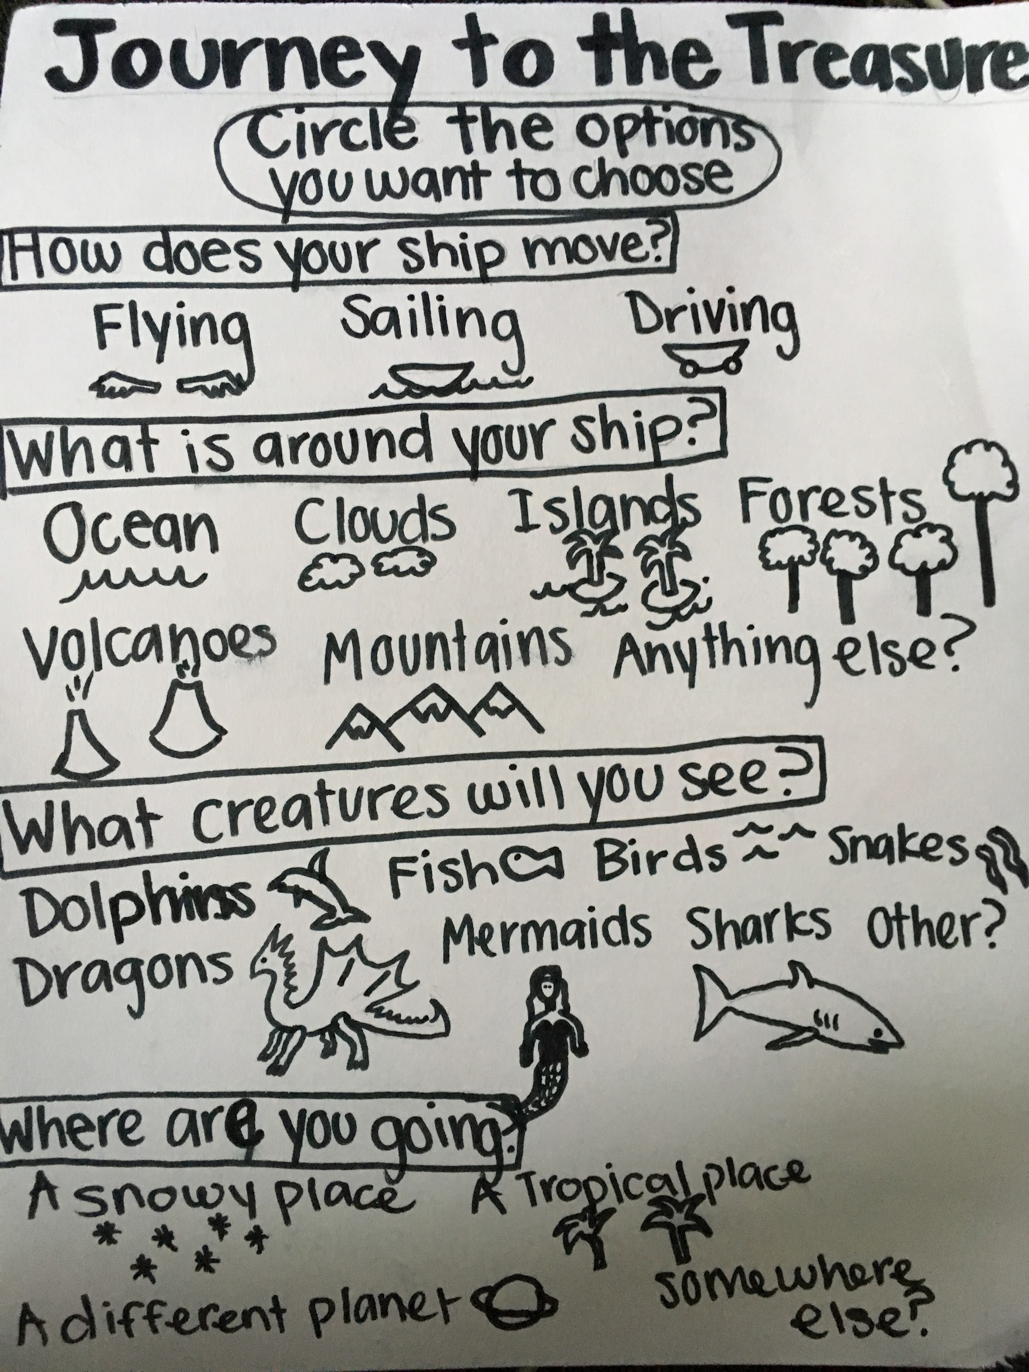

Instruction:
Give a detailed account (in bulleted form) of what you will teach. Be sure to include approximate time for each activity and instructional methodology: skills, lecture, inquiry, etc. Include motivation and ideation/inquiry where appropriate; including what student will understand as a result of the art experience

Day 1  Day 2 | Instruction - The teacher will... (Be specific about what concepts, information, understandings, etc. will be taught.) Identify instructional methodology. KNOW (Content) and DO (Skill)  Sami and Laine will go over art rules again at the beginning of class  The teacher will instruct students to sit at the carpet and the teacher will list their expectations and rules for art class.  1. Raise your hand when you want to talk  2. Be kind to others, we do not laugh at our classmates!  3. When it’s clean up time, we expect everyone to help, do not sit around doing nothing while others pick up. Cleaning up includes cleaning tables AND picking up the floor around your tables.  4. Raise your hand if you need help instead of yelling across the room at Laine or Sami  5. Share materials with your classmates  After rules and expectations, we will introduce the lesson by dressing up as pirates and reading a story about pirates.  “Today you will create your own story. You are a pirate who is ready to go on a journey to find more buried treasure, design your ship by painting on canvas with acrylic.”  We will handout lesson menus and make a pirate story together as a class. Then Laine will show her finished pirate painting and filled out lesson menu. Students will be asked to point out the options that were circled.  We will guide students to sit by their sketchbooks and hand out the lesson menus. Students will fill out the lesson menus then make a pencil sketch in their sketchbooks.  After sketching, we will do a quick demonstration about how to care for the materials (Using your own plate for mixing and not mixing paints in the center of the table.) How to clean brushes before using a different color.  We will then give students a little piece of scrap paper for them to try acrylic. We will then ask them “How is it different from watercolor (the paint we used for the last project)?”  Students will first draw a pencil sketch on their canvas (if they want to) then paint their pirate ships.  The teacher will have the room prepared before students enter:  -water cups filled  -1 paint plate per table, filled with paint  -plates for each table stacked and ready  -paintbrushes on top of stacked plates.  -final paper on each table  The teacher will instruct students to meet on the purple carpet, the teacher will say, “Ahoy maties, today we are going to create our backgrounds for our pirate ships!”  We will show the famous artworks that deal with ships (go to motivation). We will ask students, “What shapes do you see? What colors and patterns? What do you think is going on in this painting?”  Laine will show the finished pirate ship artwork with the cut out boat. Then the boat will be taken off of the artwork. “First you will create the background.”  The teacher will instruct students to sit where their sketchbooks are placed at the tables.  The teacher will instruct students to write their names on the back of their final paper and then to refer to their sketchbooks and begin to paint their backgrounds.  Students will have time now to begin to paint their backgrounds.  The teacher will instruct students when there is 20 minutes left in class.  The teacher will instruct students that it is clean up time and to look at the job poster on the board. The teacher will also instruct student to set their paintings on the black carpet.  The students will participate in a silent gallery walk and discuss what they see in their classmates backgrounds .  After they are finished, they will do a gallery walk and we will ask questions about their classmates painting “what kind of ship is this? What colors? Is it big or small? What shapes do you see?” | Learning - Students will... i.e.: explore ideation by making connections,  comparing, contrasting; synthesize possibilities for each painting technique; etc. (Be specific about what will be the intended result of the instruction as it relates to learning.) UNDERSTAND  Students will understand and remember the rules of the art classroom so that they can create in a safe environment and have respect for themselves and others.  Students will get an idea that the next project will be about pirates by participating in this activity.  Students will envision ideas by using their imagination about what their ship will look like and where it will go.  Students will explore ideation which will open their minds to new ideas and possibilities about how a pirate ship can look like.  Students will explore new painting material by using acrylic instead of watercolor which was the paint they used for the story boxes.  Students will reflect on classmate artworks and see that everyone has their own unique artistic expression, no two ships look the same.  Students will see that artworks that look complex are created by using simple shapes. This will give them encouragement to paint and create!  Students will see the finished artwork so they understand that the pirate ship goes on after the background. They can also visualize what their own artwork might look like. This also breaks down the lesson into simple steps. | Time  Total:  1 hr 45  5 min  15 min  5 min  15 min  5 min  5 min  45 min  10 min  5 min  1 min  1 min  1 min  70 min  10 min  12 min

Student reflective/inquiry activity:
Sample questions and activities (i.e. games, gallery walk, artist statement, interview) intended to promote deeper thinking, reflection and refined understandings precisely related to the grade level expectations. How will students reflect on their learning? A participatory activity that includes students in finding meaning, inquiring about materials and techniques and reflecting about their experience as it relates to objectives, standards and grade level expectations of the lesson.)
Students will participate in a gallery walk.

Post-Assessment (teacher-centered/objectives as questions):  Have students achieved the objectives and grade level expectations specified in your lesson plan? | Post-Assessment Instrument:  How well have students achieved the objectives and grade level expectations specified in your lesson plan? Include your rubric, checklist, rating scale, etc.
Did students connect their own lives to their artwork?  Did students use their sketchbook to envision ideas about how to create their pirate ship?  Did students use two-dimensional painting technique?  Did students make connections to the art created by their classmates? | Criteria Advanced Proficient Developing  Students envisioned their own idea for a pirate ship. Detailed and involved strong personal connections Somewhat detailed and involved personal connections Little detail and few personal connections  Painting displays a personalized pirate ship that they would take on a journey? Strong personal connection and use of imagination Some personal connection and some imagination Little personal connection and not any imagination

Self-Reflection:
After the lesson is concluded write a brief reflection of what went well, what surprised you, and what you would do differently. Specifically address: (1) To what extent were lesson objectives achieved? (Utilize assessment data to justify your level of achievement.) (2) What changes, omissions, or additions to the lesson would you make if you were to teach again? (3)What do you envision for the next lesson? (Continued practice, reteach content, etc.)
NA

Appendix: Include all handouts, prompts, written materials, rubrics, etc. that will be given to students.

